Laxmi Charitable Trust’s
Sheth L.U.J College of Arts & Sir M.V. College of Science and Commerce
Department of Information Technology (B.Sc.I.T Semester V)
Applied Business Analytics
Practical – 2
Roll No.: T025 | Name: Afsha Amjad Mujawar
Class: TYIT | Batch: 1
Date of Assignment: 31-07-26 | Date/Time of Submission: 31-07-26

Aim:- Describing the Distribution of a Variable:

a. Obtain a dataset and calculate descriptive statistics (mean, median, mode,
variance, etc.) for a specific variable of interest.
Code & Output:
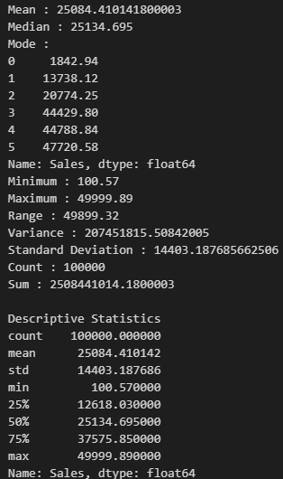
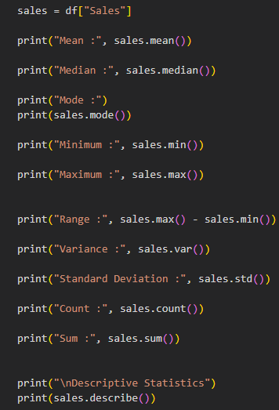
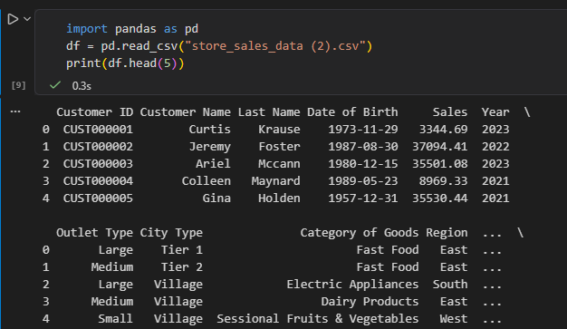

b. Create visualizations (histograms, box plots) to depict the distribution of a
variable and analyze its characteristics.
Code & Output:
